Immunize Kansas Coalition

Order Form

Order Date: __________________________Order No: ____________________

Contact Information
Customer Name: | Phone:
Address: | Email:

Please add your order information below:
Item | QTY | Language | Subtotal

Grand total*: ______________________

* Total cost does not include shipping & handling costs. Delivery/pick-up will be arranged, if possible. Otherwise, materials may be shipped for an additional charge.
Item No: |  | Description |  | Picture | Cost
1 |  | Adult Vaccine Schedule Insert.  Available in:  - English  - Spanish  - Dari  - Pashto  - Arabic  - Haitian Creole |  | 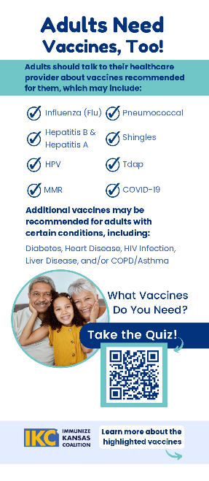 | $15/100
2 |  | Kids Vaccine Schedule Insert  Available in:  - English  - Spanish  - Dari  - Pashto  - Arabic  - Haitian Creole |  | 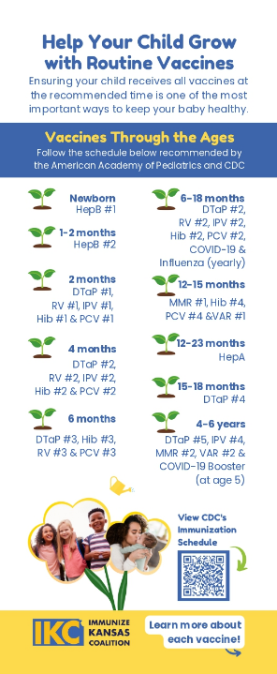 | $15/100
3 | VFOF Booklet in  Available in:  - English  - Spanish |  |  |  |  | $15 each
4 | VFOF One-Pagers (Key Facts)-  Available in:  - English  - Spanish |  |  |  |  | $27/100
5 | Pregnancy Insert Card  Available in:  - English  - Spanish |  |  |  |  | $15/100
6 | Respiratory Viruses Brochure-  Available in:  - English  - Spanish |  | 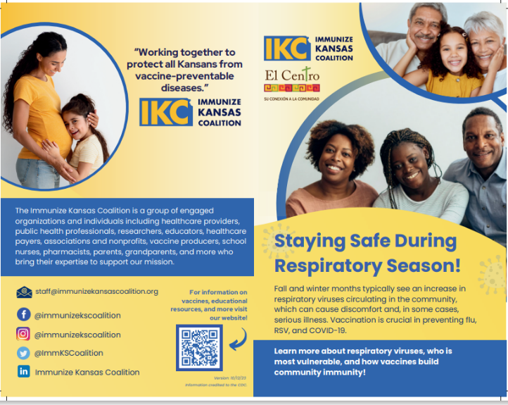 |  |  | $27/100
7 | Bridge Program Insert Cards  1 version - English on one side, Spanish on the other |  |  |  |  | $15/100

